POSTED DISCLOSURE INFORMATION
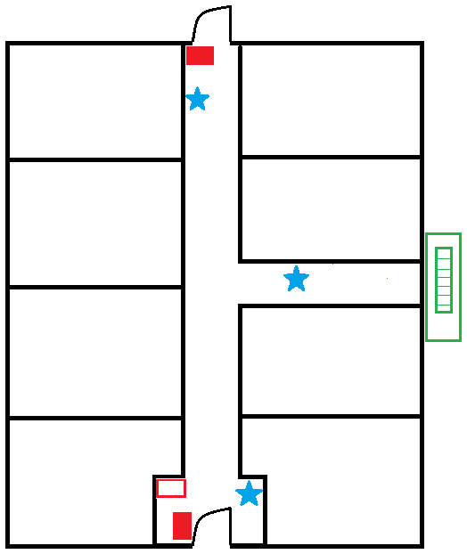
EXIT
EXIT

SAMPLE

FIRE ESCAPE
ONLY

EXIT

EXITS SHALL REMAIN UNOBSTRUCTED AT ALL TIMES!!!
-FIRE ALARM PULL STATION

-FIRE EXTINGUISHER
-FIRE ALARM PANEL UL CERTIFICATE #
UL EXPIRATION DATE
-FIRE ESCAPE

(Service Date)
_(Service Date)

_(Service Date

FIRE DEPARTMENT VIOLATION HOTLINE 415-558-3300

